CO3201 Computer Science Project

A Scrabble Computer Player Interim Report

Kamran Ahmed

22/11/2024

School of Computing and Mathematical Sciences, University of Leicester

Contents

1. Introduction 1

1.1 Aims and Objectives 1

1.1.1 Aim 1

1.1.2 Objectives 1

2. Literature Review 2

2.1 Target Audience 2

2.2 Existing Systems 2

3. Requirements 5

3.1 Functional Requirements 5

3.2 Non-Functional Requirements 6

4. Outline of Specification and Design 6

4.1 Front-End (User Interface) 7

4.2 Back-End (Game Logic) 7

4.3 AI Module 7

4.4 Security 7

5. Planning and Timescales 8

5.1 Gantt Chart 8

5.2 Milestones 9

6. References 9

**DECLARATION**

All sentences or passages quoted in this report, or computer code of any form whatsoever used and/or submitted at any stages, which are taken from other people’s work have been specifically acknowledged by clear citation of the source, specifying author, work, date and page(s).

Any part of my own written work, or software coding, which is substantially based upon other people’s work, is duly accompanied by clear citation of the source, specifying author, work, date and page(s).

I understand that failure to do this amounts to plagiarism and will be considered grounds for failure in this module and the degree examination as a whole.

Name: Kamran Ahmed

Signed: Kamran Ahmed

# 1. Introduction

I am creating a Scrabble game for my project. Scrabble is a word-based game. The player must use letter tiles to form words within a grid. These words are formed by connecting letters either horizontally or vertically. Words earn points and once all the letters are drawn, the person with the most points wins the game.

## 1.1 Aims and Objectives

### 1.1.1 Aim

The aim of this project is to create a fully functional Scrabble game that combines engaging Graphical User Interface (GUI) with intelligent gameplay mechanics against an AI opponent. This provides an enjoyable experience whilst displaying advanced programming techniques.

### 1.1.2 Objectives

A series of crucial objectives must be achieved for this project to be successful:

* **Research/Preparation –** Learn the rules and mechanics of scrabble to ensure accurate replication. Explore GUI ideas and understand best practices to design.
* **Design –** Define overall system architecture and plan interactions between modules in an efficient system.
* **Developing a User-Friendly interface** – Engineer an aesthetically appealing GUI mimicking the traditional Scrabble board layout whilst ensuring smooth user interaction
* **Implement Key Gameplay Mechanics –** Accurately represent the official rules of Scrabble allowing for a familiar experience, whilst integrating a scrabble dictionary and developing a scoring system to determine a winner. Add customise options and save/load functionality.
* **Design and Implement AI Opponent –** Create an AI opponent capable of challenging the user at multiple skill levels, whilst also being able to play the game effectively.
* **Testing and Debugging –** Perform rigorous testing of all features. Ensure everything runs smoothly and all functions are incorporated seamlessly. Test cases such as incorrect word input etc. to see if correct response is outputted.
* **Documentation –** Provide comprehensive documentation of each step during the project.

# 2. Literature Review

## 2.1 Target Audience

After extensive research, I concluded that Scrabble has a vast audience and caters to many different demographics. For the casual players, it gives a fun, interactive experience that allows players to stimulate their brains. Students or educational users who want to use it to increase their vocabulary and linguistic ability, or just gaming enthusiasts who want to have fun against a challenging AI. Scrabble is also not restricted to an age range, “The average age at the first participation in a SCRABBLE tournament was 38.78” [1]. This shows the average age is lower than expected, essentially close to median. Its simple rules make it easy to follow for anyone and it is designed to cater to anyone’s skill level and keep them engaged.

## 2.2 Existing Systems

To get a gauge on the approach I will take in designing my scrabble game, I investigated existing releases and analysed things they did well that I could take inspiration from. Furthermore, to see if anything was missed that I could add to my own to be innovative.

The first system I researched was Scrabble GO, one of the most popular digital interpretations of Scrabble. The main features I liked was the colourful and simplistic appearance of the app, making it appealing to the user and keeps them engaged. It also incorporates features such as chests so the user can keep playing to work towards unlocking new tiles and other features, whilst these features don’t affect gameplay just the aesthetic appeal.

*Figure 2.1*

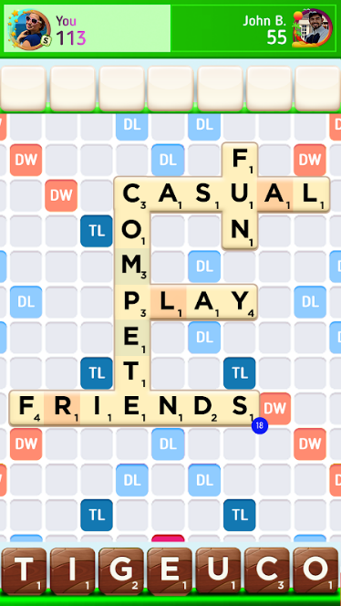

Here figure 2.1 is displaying in-game footage [5]. You can see the colourful and simplistic approach, that would appeal to both younger and older audiences. The player has different colour tiles in their deck which they unlocked through game progression, giving user the incentive to keep playing to unlock more different styles. This interpretation takes a classic game and takes a modern approach to appeal to a wider audience and give ease of access.

The second interpretation I researched was playscrabble.com. This is the most popular version of Scrabble available on the web. Whilst it also takes a modern and simplistic approach, it implements other features that the mobile version does not. This allows for a slightly different but just as engaging experience whilst playing through the game, adding layers of complexity not previously offered.

*Figure 2.2*

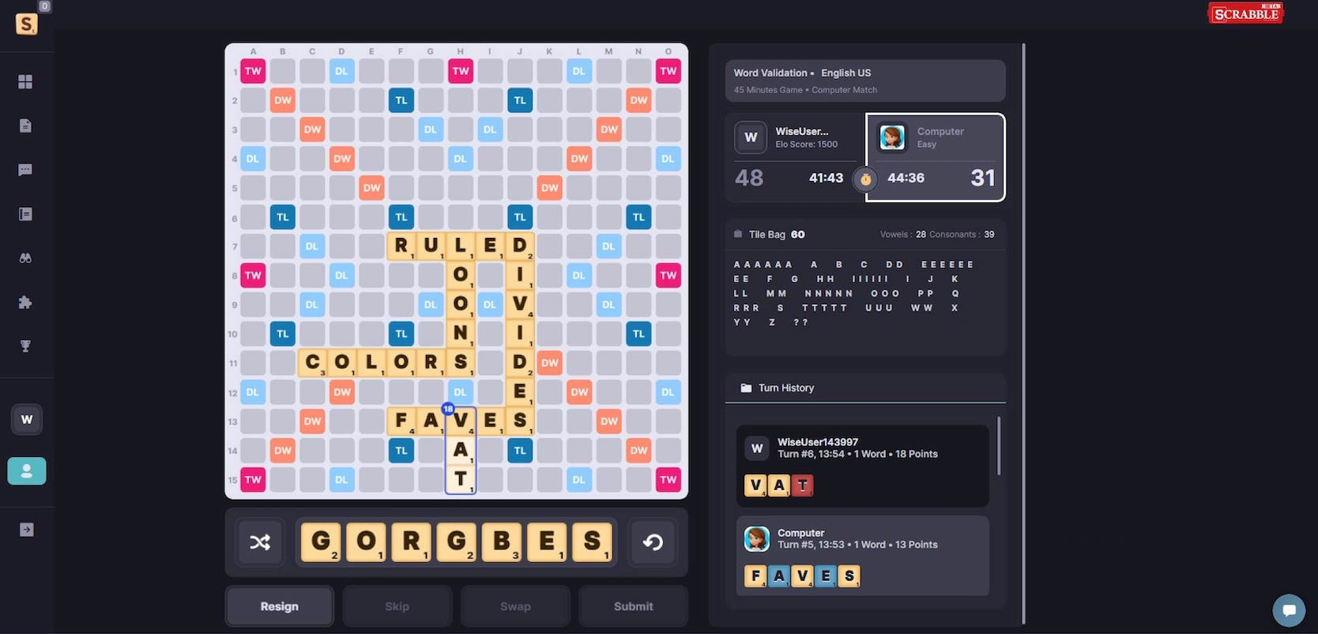

Figure 2.2 shows in-game footage of playscrabble.com. [6] Whilst it shares a lot of similarities with its mobile compatriot, you can also admire the extra level of detail integrated to produce a more immersive experience. The timer incorporates a different experience, giving the player time restrictions adds a whole new dynamic and allows for more margin for error and requires a lot more composure and intelligent decision making, Also, the bigger screen allows more information to be simultaneously displayed such as the turn history, letters remaining and the timer etc. Overall, the web version incorporates a lot more features and makes it’s a limitless experience due to the vast options that the user has.

Looking and playing through these existing systems helped me understand Scrabble and how I am going to implement my interpretation of it. Whilst you cannot alter the rules, I plan to enhance the visual appeal and add features such as a dynamic board, tile power modifiers, word themes, advanced scoring/analytics to help improve your game, more customization options, ability to actively look up words whilst playing, leaderboards etc. I will aim to incorporate as many of these as possible.

# 3. Requirements

A crucial stage of any project is outlining the functional and non-functional requirements for my system, which I will do now. This is imperative as “Functional requirements explain how the system must work, while non-functional requirements explain how the system should perform.” [2]

## 3.1 Functional Requirements

These are the features required to complete the Scrabble game experience:

* **Core Gameplay Mechanics** 
  + A 15x15 board must be displayed which contains double and triple letter spaces
  + Incorporate a “Dynamic Board” where the double and triple spaces can change positions
  + Allow users to place and remove tiles randomly from a predefined tile bag
  + Use the preloaded dictionary to validate words and in turn score the users accordingly
* **Player Experience**
  + Create a skill-based AI opponent and allow alternate turns between the user and the AI, with clear indictors on whose turn it is
  + Integrate different difficulty opponent
  + Allow the user to save and load games
* **User Interface**
  + Design an appealing Graphical User Interface (GUI) that allows seamless gameplay
  + Design features to aid users should they need the support
* **Extras**
  + Add an option for “Word Themes” where the word must align with a certain theme, making it more of a challenge.
  + Integrate game analytics to help the players study and perform better through more practise.

## 3.2 Non-Functional Requirements

These will indicate how the system should perform:

* **System**
  + System must respond to user actions (e.g. placing tiles) within seconds. AI opponent must also execute within seconds.
* **Visuals**
  + Board and dynamic board must load within seconds. Clear visual indicators should also be present to show whose turn it is as well as tile placement.
  + Interface must be intuitive and user-friendly.
* **Reloadability**
  + Should be able to save games and load them later.
* **Customisation**
  + Allow users to customise their board games, including themes, tile styles etc.
  + Allow for specific word themes within a game.
* **Cross-Functionality**
  + Ensure the game runs smoothly on all platforms.
* **Scalability**
  + Integrate the leaderboard that will slowly grow over time
  + Ensure capability to further update the game with new tiles, boards etc.

# 4. Outline of Specification and Design

The architecture for this Scrabble game is divided into three components: Front-end which is the user interface, Back-end which is the game logic and the Artificial Intelligence module. There are also other smaller components such as the data management layer and innovative features etc. but these are the main three

## 4.1 Front-End (User Interface)

I will be using PyQt for my front end, I have chosen this for its graphical capabilities to produce a modern interface. It can support custom themes, smooth animations and provide visuals for turn indicators and tile placement. It can also provide plenty of customisation options.

Overall, it ensures a professional, aesthetically appealing interface whilst maintaining ease of use.

## 4.2 Back-End (Game Logic)

For the back end, I will be using Python with SQLite. This will allow me to simplify complex game logic whilst also handling advanced analytics. Also, SQLite is perfect for storing game progress and leaderboards and seamlessly integrate it all within Python. It allows for saving and loading games and supports game customization.

## 4.3 AI Module

The AI opponent will be incorporated using Minimax via Python. Its versatile language, endless libraries and easy readability makes it ideal to develop my AI integration.

Minimax is a decision-making algorithm widely used in turn-based games such as Scrabble. By using depth control, you can adjust the AI difficulty to suit a wide range of skill levels.

## 4.4 Security

Security is a vital part for any system to successfully run. “Common Cybersecurity Threats: Data Breaches, Distributed Denial of Service (DDoS) Attacks, Malware and Ransomware, Account Takeovers, Cheating and Exploits.” [3]

To counteract I will integrate multiple preventative measures, whilst using software such as SQLite databases etc. I will also employ monitoring/logging and rule enforcement to ensure to eradication of potential cheating within the game as “Cheating damages the gamer experience which leads to a decline in viewership and sponsorship opportunities.” [4]

# 5. Planning and Timescales

With any project, one of the most important steps is planning and making sure you set deadlines to complete each task to ensure the project is finished in good time and alleviate yourself of stress. I will be outlining the timescale of Semester 1 and Semester 2 whilst also representing them using Gantt charts.

## 5.1 Gantt Chart

*Figure 5.1*

Figure 5.2 displays my outline for how I will be completing the project over the coming months. Throughout the first semester, I researched the rules of scrabble, as well as outlining the design for the system. Throughout the second semester I will begin creating and refining the game itself, tuning the game to meet my criteria in preparation for the interview and presentation.

## 5.2 Milestones

* The first milestone will be the completion of this **interim repor**t on November 22nd, 2024. This will be the accumulation of the research I have done and the plan moving forward.
* The next major milestone will be the completion of the **interview** around 17th February 2025. This will be the preparation for my presentation in May.
* Next milestone will be the **dissertation** submission around 2nd May, summarising the year’s work.
* After this, it will **be software system** submission highlighting the work in my dissertation and ending with my **Mini Viva with Presentation**, a complete wrap up of my whole project and an oral examination of everything I have worked on.

# 6. References

[1]

J. H. Moxley, K. A. Ericsson, and M. Tuffiash, “Gender differences in SCRABBLE performance and associated engagement in purposeful practice activities,” *Psychological Research*, vol. 83, no. 6, pp. 1147–1167, Aug. 2017, doi: <https://doi.org/10.1007/s00426-017-0905-3>. Accessed: 19th November 2024.

[2]

P. Gorbachenko, “Functional vs Non-Functional Requirements [Updated 2021],” *enkonix.com*, Apr. 09, 2021. <https://enkonix.com/blog/functional-requirements-vs-non-functional/>. Accessed: 19th November 2024.

‌ [3]

“Data Security in Gaming | Protecting Gamers Worldwide,” *Qable.io*, 2024. <https://www.qable.io/blog/is-data-security-important-for-gaming-industry>. Accessed: 21st November 2024.

[4]

D. Blechner, “The cost of cheating in online gaming: How it affects the industry,” *Quago- In-game behavioural analytics*, Nov. 26, 2023. <https://quago.io/blog/the-cost-of-cheating-in-online-gaming/>. Accessed: 21st November 2024.

[5]

“Blocked,” *Uptodown.com*, 2024. <https://scrabble-go.en.uptodown.com/android>. Accessed: 21st November 2024.

[6]

“11 Epic Scrabble Games to Play Online With Friends,” *Yourdictionary.com*, 2021. <https://wordfinder.yourdictionary.com/blog/9-epic-scrabble-games-to-play-online-with-friends/>. Accessed 21st November 2024.

‌

‌

‌